Lab 4 – IE 6200 - Sec 07 - Omkar Kalange

1. bikes_df=read.csv('Bluebikes_assignment.csv', sep=',', header=TRUE)
2. Start Station - Washington St at Rutland St

End Station - MIT at Mass Ave / Amherst St

1. Start PMF –

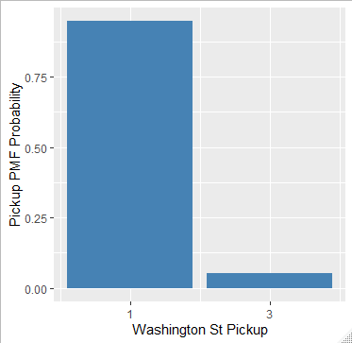

1. Start CDF

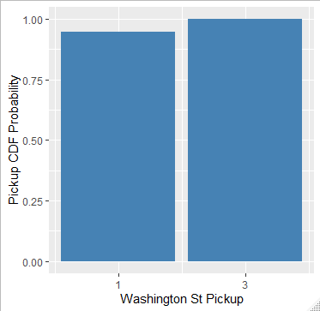

1. End PMF –

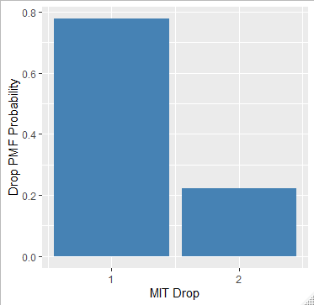

1. End CDF –

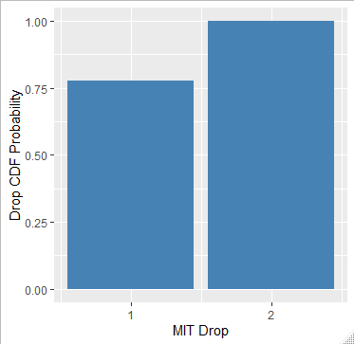

1. Expected value
2. Start time –

weighted.mean(was_freq$count,was_freq$pickuppmf)

[1] 1.105263

1. End time –

weighted.mean(mit_freq$count,mit_freq$droppmf)

[1] 1.222222

1. Joint Probability

> joint_freq

1 2

1 25 20

3 8 3

1. Correlation coefficient

> cor(was_8$count1[0:100], mit_8$count2[0:100])

[1] -0.06255427